Living with Black Bears in Virginia

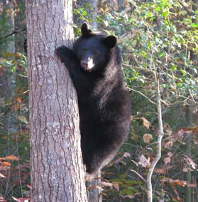What you do really matters.
We can work together to
keep bears wild!

Black bears and human populations commonly coexist in many parts of North America. Black bears occur throughout most of the Commonwealth, and residential areas of Virginia are encroaching into forested lands and habitats commonly used by wildlife as human populations are also growing and spreading across most areas of Virginia.

Where Are the Bears?
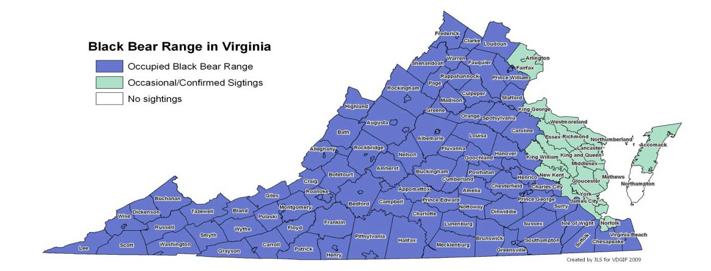
While the highest concentration of bears occurs in the Blue Ridge and Alleghany Mountains and around the Great Dismal Swamp, bears can be seen just about anywhere in Virginia. According to data from recreational sightings, hunter harvest, road kills, and VDGIF field staff, bears occur in at least 92 of Virginia's 98 counties and cities.

Black bears capture human admiration and interest like few other wildlife species. Citizens, communities, local governments, and VDGIF share the responsibility in preventing problems and keeping bears wild.

Many people enjoy the opportunity to see bears in the wild. However, when human-related foods become available to bears, problems may occur. Residents and visitors to Virginia can minimize negative interactions with bears by following some simple guidelines.

Residential Bear Problems
Bears are highly adaptable, intelligent animals and may learn to associate human dwellings with food. Bears are attracted to residential areas by the smell of foods people commonly put out around their homes. In reality most problems caused by bears are really “people problems”. It is up to humans to change their own behaviors to avoid conflicts.
 The most common food attractants are bird feeders, garbage, beehives, and pet food. Grills, livestock feeds, and compost can also attract bears.
 Residential bear problems may occur at any time of year, but are more common when natural food supplies are limited, usually in the spring or in years when natural nut and berry production is low.
 Most common bear problems have simple solutions. Typical problems involve turned-over garbage containers, trash littered across the yard, damaged birdfeeders, or bears coming onto porches to eat pet food or get into coolers. However, bears that learn to associate food with people can cause property damage in their search for food around houses.

If addressed promptly, problems are often quickly resolved. After a few failed attempts to find food around homes, bears will usually leave the area in search of their natural wild foods.
If problems are ignored, property damage not only can get worse, but bears may lose their distrust of humans and come to rely solely on unnatural foods. Habituated bears can pose public safety concerns and in some unfortunate circumstances may have to be killed. The responsibility to prevent this from happening belongs to everybody.
SHARED RESPONSIBILITY
VDGIF will not trap or relocate a bear that is eating from your trash or birdfeeder. It is your responsibility to remove the attractants from your property once a bear discovers the food source. If needed, we can help you identify the attractant so it can be removed and offer advice for deterring bears from your property.

You Can Keep Bears Wild
Black bears have a natural distrust of humans, are shy, and usually avoid people. However, bears may be attracted to food sources in residential areas.
 Remove the bird feeders. It is best not to put out food for birds from April - November. Instead, plant native seed- bearing plants or use water features to attract birds to your home.
 Secure your garbage. Store garbage indoors, in a shed, garage, or in a bear-proof container. Put garbage out on the morning of pickup, not the night before, or take it to the dump frequently.
 Pick up pet food. Feed pets only what they will eat in a single feeding or feed them indoors. Remove all uneaten food. Do not leave food out overnight.
 Do not put meat scraps in the compost pile. Keep compost away from house.
 Pick up and remove ripe fruit from fruit trees and surrounding grounds.
 Clean the grill often. Do not dump drippings in your yard. Run the grill an extra 5 minutes to burn off grease.
 Install electric fencing to protect beehives, dumpsters, gardens, compost piles, or other potential food sources.

 Don’t store food, freezers, refrigerators, or trash on porches.
 Use harassment techniques in conjunction with removing the attractant to get the bear to move off your property. Paintballs are a great tool for hazing. They are nonlethal, won’t harm the bear if shot at the rump, but are painful enough to get the bear moving away from homes.
 Talk to your neighbors. Make sure your neighbors and community administrators are aware of the ways to prevent conflicts with bears.
 Learn about black bears!

Your Role
You can help manage the Commonwealth's black bear population by keeping your property clear of food attractants and communicating with your neighbors to resolve community bear concerns.

Know the facts. Learning about bears will prevent negative interactions and dispel unfounded fears. Distinguishing nervous behaviors (like huffing or jaw popping) from inquisitive ones (like standing up to get a good whiff of something interesting) can help make encounters positive.
Prevention and cooperation. You can help manage the bear population by keeping your property clear of food attractants and communicating with your neighbors to resolve community bear concerns. It is illegal to deliberately or inadvertently feed bears.
Respect the bear’s space. If you see a bear, enjoy watching from a distance. If you come into close contact, back away slowly and remember that bears have a natural distrust of humans and will run when given a safe escape route. If it is up a tree, leave it alone. Keep people and pets away from the tree to allow the bear to leave your property.
Let the bear know it is not welcome. Often a bear in your yard is just passing through and, if it finds no food, will simply move on. Don’t allow the bear to feel comfortable in your yard. After ensuring the bear has an escape route, make lots of noise to encourage it to leave. Remove any non-natural foods that attracted the bear.
Report unresolved problems or damage. If you experience a bear problem after taking appropriate steps of prevention, you may seek additional assistance by contacting the Wildlife Conflict Helpline.
DELIBERATE & INADVERTENT FEEDING OF BEARS IS ILLEGAL
It shall be unlawful for any person as defined in § 1-230 (Code of Virginia) to place, distribute, or allow the placement of food, minerals, carrion, trash, or similar substances to feed or attract bears. Nor, upon notification by department personnel, shall any person continue to place, distribute, or allow the placement of any food, mineral, carrion, trash, or similar substances for any purpose if the placement of these materials

VrDesuGltIs iFn ’tshe Rproesleence of bears.

VDGIF has established bear guidelines that promote public safety, protect property, and conserve bear populations. Whenever possible, VDGIF’s approach to managing problem bears encourages the coexistence of bears and humans. The specific response to bear issues is determined by public concerns and safety, type and extent of damage, black bear biology, animal welfare, and available control methods.

When you call for assistance, a staff member will discuss the problem with you. In most cases, a telephone call will be all that is necessary to find successful solutions (usually the removal of attractants). At times, a VDGIF biologist may visit your property to discuss additional options.

Things to Remember in Bear Country

If You Encounter a Bear at Home:
There are no definite rules about what to do if you meet a bear. In almost all cases, the bear will detect you first and leave the area. Unprovoked bear attacks are very rare, and have never been documented in Virginia. If you do meet a bear here are some suggestions:

- Stay calm. If you see a bear and it has not seen you, calmly leave the area. As you move away, make noise to let the bear discover your presence.
- Stop. Back away slowly while facing the bear.
- Give the bear plenty of room to escape. Bears rarely attack people unless they feel cornered or provoked.
- Do not run or make any sudden movements. Running could prompt the bear to give chase, and you cannot outrun a bear. If on a trail, step off the trail and slowly leave the area.
- If there is a bear in your yard and it approaches you, make yourself look big and make loud noises. Remain at a safe distance and throw rocks to make the bear feel unwelcome.
- If there is a bear in your house prop open all doors to the outside and get out of the way of the exit. Never close a bear into a room. Make noises and yell at bear to leave the house. Don't approach the bear but make sure it knows it is violating your territory.
- If you surprise a bear speak softly. This may reassure the bear that you mean it no harm.
- Fight back. If a black bear attacks you, fight back. Black bears have been driven away when people have fought back with rocks, sticks, binoculars and even their bare hands.

If You Encounter a Bear While Camping:
- Do not store food, garbage, or toiletries in your tent!
- Keep your camp clean.
- Store your food safely. Use bear-proof containers. Metal ammunition cans ($10-20) and Bear Canisters (approximately $50-60) are easily packed and transported.
- Keep your tent and sleeping bag free of all food smells.
- Store the clothes you wore while cooking or eating with your food.
- Burn all grease off grills and camp stoves.
- Wipe table and clean eating area thoroughly.
- Store food and coolers suspended from a tree at least 10 feet off the ground and four feet out from the tree trunk.
- Dispose of garbage properly. Secure it with your food and then pack it out.
- Do not burn or bury the garbage.
- Sleep away from food areas. Move some distance away from your cooking area or food-storage site.
- Store toiletries with your food; the smell of toiletries may attract bears. Scents and use of perfume or cologne is sometimes an attractant to bears.

A Bear Outside Your Tent: If you hear a bear or other animal outside your tent make sure it is aware that there is a human inside by using a firm monotone voice. Turn on a flashlight or lantern. If the bear enters the tent fight back and yell. Many bears have been driven off this way.

If You Encounter a Bear While Hiking:
- Hiking at dawn or dusk may increase your chances of meeting a bear.
- Use extra caution in places where hearing or visibility is limited, such as brushy areas, near streams, where trails round a bend and on windy days.
- Reduce your chances of surprising a bear on the trail by making noise, talking or singing.
- Leave your dog at home or make sure it is on a leash. Off leash dogs are the most common cause of backcountry negative interactions with bears.

Common Black Bear Myths

Myth: A bear standing on its hind legs is about to charge or attack.
Fact: A bear stands on its hind legs to get a better view and smell of the surroundings. This is not an aggressive posture, just a way to determine who or what piqued its interest.

Myth: Bears are dangerous predators.
Fact: Although classified as carnivores, black bears are omnivores, and opportunistic feeders. This means that they eat both plants and animals. Over 80% of their diets consist of vegetation, fruit, and nuts. The remainder includes mostly insects and larva, carrion, fish, and occasionally small mammals.

Myth: One of the most dangerous encounters is getting between a mother black bear and her cubs.
Fact: Because black bears can tree their cubs, it is rare for them to injure a person in that situation. Black bear cubs are great at climbing and will be sent up a tree if the mother bear feels nervous about a situation. The mother bear will either run off to lead the danger away or stay close by until the perceived threat passes. Just like with any young animals you never want to try to get near them. If you see a mother bear and cubs give them some space, be quiet, and retreat slowly.

Myth: Bears are unpredictable.
Fact: Bears use body language and vocalizations to show their intentions. Most times people interpret nervous behavior incorrectly as aggressive behavior. Learning about bear behavior can be beneficial to people who travel in bear country.

Myth: Bears have poor eyesight.
Fact: Bears see in color and have good vision similar to humans

Myth: Shooting or relocating a bear that has been attracted to your property because of a food source will solve the problem.

Fact: Removing a bear and not the attractant will only create a newly available habitat niche so another bear can move right back in, creating a vicious cycle of killing.

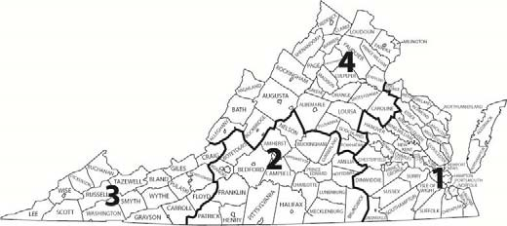

VDGIF Administrative Regions

Charles City (Region 1) (804) 829-6580

Forest (Region 2) (434) 525-7522

Marion (Region 3) (276) 783-4860

Verona (Region 4) (540) 248-9360

Fredericksburg (Region 4) (540) 899-4169

Contact us for more information
WILDLIFE CONFLICT HELPLINE (855) 571-9003

More Information

Do-it-yourself instructions for electric fencing and trash can retrofit, Black Bear Management Plan, links, videos and more. Visit:www.dgif.virginia.gov/wildlife/bear/

To purchase a bear resistant products please visit http://www.lwwf.org/index.php/products-testing for links to bear-tested products through the IGBC Bear-Resistant Products Testing Program.

You may also find a direct link to the pdf here:
http://www.igbconline.org/index.php/safety-in-grizzly-country/bear-resistant-products/igbc- certified-bear-resistant-products

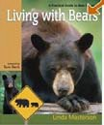Websites with lots of useful information for homeowners, municipalities, HOAs and Communities

Living with Bears Website-Tips for http://livingwithbears.com/

Bear Smart Community Guidelines and Bear Information: www.bearsmart.com

Living with Wildlife Foundation Electric Fence and Refuse Guides: http://www.lwwf.org/

